

**American International University-Bangladesh (AIUB)**  
 Department of Computer Science

Faculty of Science & Technology (FST)

**TravelBuddy : Local Travel Companion**

**Semester: Fall 25-26**

|  |  |  |
| --- | --- | --- |
| ***Group: 03*** | | ***Section: V*** |
| **SL** | **Student Name** | **Student ID** |
| 11 | SHANTUNU BARUA | 23-53712-3 |
| 25 | M.SAKIB SADMAN ARIAN | 23-54986-3 |
| 36 | MD. ARAFAT RAHMAN SAMIR | 23-55488-3 |
| 37 | RAYEAN SADIK | 23-55508-3 |

Table of Contents

1. Project Proposal xx

1.1 Background to the Problem xx

1.2 Selection of Process Model xx

2. Software Requirements Specification (SRS) / PRD xx

2.1 Scopes and Features xx

2.2 User Story Table xx

2.3 Requirements Traceability Matrix xx

2.3.1 Functional Requirements xx

2.3.2 Non-Functional Requirements xx

3. Software Design xx

3.1 System Deisgn xx

3.2 UI Deisgn using Figma xx

4. Git Workflow xx

5. Software Testing xx

6. Conclusion xx

# PROJECT PROPOSAL

## ****Background to the Problem****

Tourists often face problems when planning trips, such as finding affordable hotels, restaurants and transportation within their budget. They also struggle to decide which places to visit first and how to ensure safety while traveling in unknown places. Most travel apps focus on expensive options and do not provide budget-friendly recommendations or complete travel guidance.

**TravelBuddy: Local Travel Companion** is designed to provide a smart and user friendly tourists plan their trips, find safe and affordable options and have a well organized travel experience.

## ****Selection of Process Model****

We chose the Agile Scrum model for the TravelBuddy project due to its flexibility, iterative development approach and strong support for changing requirements. As the system involves multiple stakeholders such as tourists, service providers, authorities and administrators their needs may evolve during development. Scrum’s sprint based allows the team to deliver working features incrementally, enabling early feedback and continuous improvement. Key functionalities such as trip planning, booking services, and safety alerts can be developed, tested, and refined across multiple sprints. Scrum also promotes effective communication through regular ceremonies like sprint planning, daily stand-ups, sprint reviews and retrospectives, which is suitable for a small team of four members working within limited academic timelines.

We did not used others model due to

**Waterfall Model:** The Waterfall model follows a rigid, sequential approach with fixed requirements. It was not chosen because it does not support requirement changes or early user feedback which are essential for a dynamic travel application like TravelBuddy.

**V-Model:** The V-Model emphasizes testing and validation, it requires extensive upfront planning and documentation. This rigidity makes it unsuitable for a project that benefits from rapid prototyping and frequent user feedback.

**Extreme Programming (XP):** XP focuses heavily on coding practices such as pair programming and test driven development. However, it requires continuous customer involvement and lacks structured sprint planning, making it less suitable for managing diverse features and stakeholders.

**Dynamic Systems Development Method (DSDM):** DSDM provides strong governance and prioritization but involves complex roles and heavy documentation. This overhead is not practical for a small academic team.

**Feature Driven Development (FDD):** FDD is more appropriate for large teams and complex systems with specialized roles. Its formal structure and feature ownership model do not align well with the collaborative and flexible needs of the TravelBuddy project.

Scrum is an agile framework that delivers software incrementally through time boxed sprints which allow continuous feedback and adaptation. For the TravelBuddy project, Scrum provides an effective balance between structure and flexibility, enabling the team to prioritize important features early while continuously refining the system based on user and stakeholder feedback.

## 2. SOFTWARE REQUIREMENTS SPECIFICATIONS (SRS) / PRODUCT REQUIREMENTS DOCUMENT (PRD)

## 2.1 Scopes and Features

1. **User Registration and Authentication**

* Multi-role registration: tourists, service providers, authorities, administrators
* Registration via email or phone number with **OTP verification**
* Secure login and authentication
* Password recovery with OTP validation
* Session management and role-based access

1. **Profile Management**

* View and update personal information and preferences
* Tourists: travel interests, budget, safety priorities, preferred destinations
* Service providers: business details, pricing, availability, verification documents
* Data validation and audit trail for security

1. **Destination Search and Discovery**

* Search destinations using filters: distance, ratings, price, safety, category
* Display destination info: description, estimated costs, nearby attractions
* Integration with maps for location visualization
* User reviews and ratings aggregation

1. **AI Recommendation Engine**

* Personalized recommendations based on user preferences, bookings and behavior
* Factors: season, weather, trending locations, budget
* Continuous learning to improve recommendation accuracy
* Provides rationale for suggestions to build user trust

1. **Smart Trip Planning and Itinerary Generation**

* Generate optimized single-day or multi-day itineraries
* Consider preferences, time, budget, and logistics
* Route optimization for travel time and cost efficiency
* Editable itineraries with real-time feasibility validation

1. **Service Search and Booking**

* Search hotels, restaurants, transportation, and other services
* Filters: price, ratings, availability, location, amenities
* Booking request submission and provider acceptance/rejection
* Real-time availability and booking status tracking

1. **Payment Processing**

* Multi-method payment support (cards, mobile wallets, online banking)
* Secure payment gateway integration with encryption (PCI-DSS compliant)
* Real-time payment validation and booking confirmation
* Receipt generation and payment history tracking
* Refund handling for cancellations

1. **Safety Alerts**

* Real-time safety notifications based on user location and planned destinations
* Authorities can broadcast warnings: weather, health, security, traffic
* Multi-channel notifications: push, in-app, SMS
* Alert categorization by severity

1. **Emergency SOS and Live Location Sharing**

* One-touch SOS activation from any screen
* Automatic GPS capture and alert transmission to authorities
* Real-time location tracking and map visualization
* Two-way communication with emergency responders
* Emergency contact notification

1. **Rating and Review System**

* Multi-dimensional service and destination ratings
* Verified reviews from actual users
* Review aggregation and statistical display
* Service provider responses and community voting

## ****2.2.1 User Story Table****

|  |  |  |  |
| --- | --- | --- | --- |
| **As a/an** | **I want to** | **So that** | **Acceptance Criteria** |
| Tourist | Register using email or phone number | I can access the TravelBuddy platform | OTP verification completed then Account activated |
| Log in to my account | I can plan trips and manage bookings | Successful login opens personalized dashboard |
| View and update my profile | My preferences stay current | Profile changes are saved with confirmation |
| Search destinations using filters | I can find places that match my needs | Destinations shown with ratings, cost, safety, and location |
| Receive AI-based recommendations | I discover suitable destinations | Personalized recommendations displayed |
| Generate a smart trip plan | My trip is optimized | Day wise itinerary with route and time optimization |
| Search and book services | I can arrange travel facilities | Booking confirmation generated |
| Receive safety alerts | I stay informed about risks | Alerts appear based on location |
| Activate SOS emergency | I get help in danger | Authorities receive live location |
| Rate and review services | Others benefit from my experience | Verified review published |
| Service Provider | Register business with documents | I can offer services | Registration submitted for verification |
| Manage service details and availability | Tourists get updated information | Changes reflect immediately |
| View and manage bookings | I control reservations | Accept/reject option available |
| Create promotions | I attract more tourists | Offers visible to users |
| Authority | Publish safety alerts | Tourists remain safe | Alerts broadcast instantly |
| Respond to SOS alerts | Emergency response is faster | Location and user details shown |
| Approve destinations | Only safe places are listed | Approved destinations receive badge |
| Monitor complaints | Service quality is maintained | Complaints tracked and resolved |
| Admin | Verify users and providers | Platform remains trustworthy | Approval/rejection recorded |
| Manage user accounts | Policy violations are controlled | Suspend/ban actions applied |
| Monitor system operations | Platform runs smoothly | Admin dashboard shows system status |
| Server/System | Automatically verify accounts upon registration | Users receive immediate confirmation and platform access | OTP generated automatically OTP sent via email Account activated after OTP validation Errors handled |
| Process payment transactions securely | Bookings are confirmed upon successful payment | Payment gateway integrated, Booking confirmation triggered |
| Validate booking payments with service providers | Both tourists and service providers receive accurate booking and payment confirmations | Real time payment status, Booking records updated Confirmation delivered to tourists and providers |

## ****2.2.2 Trello****

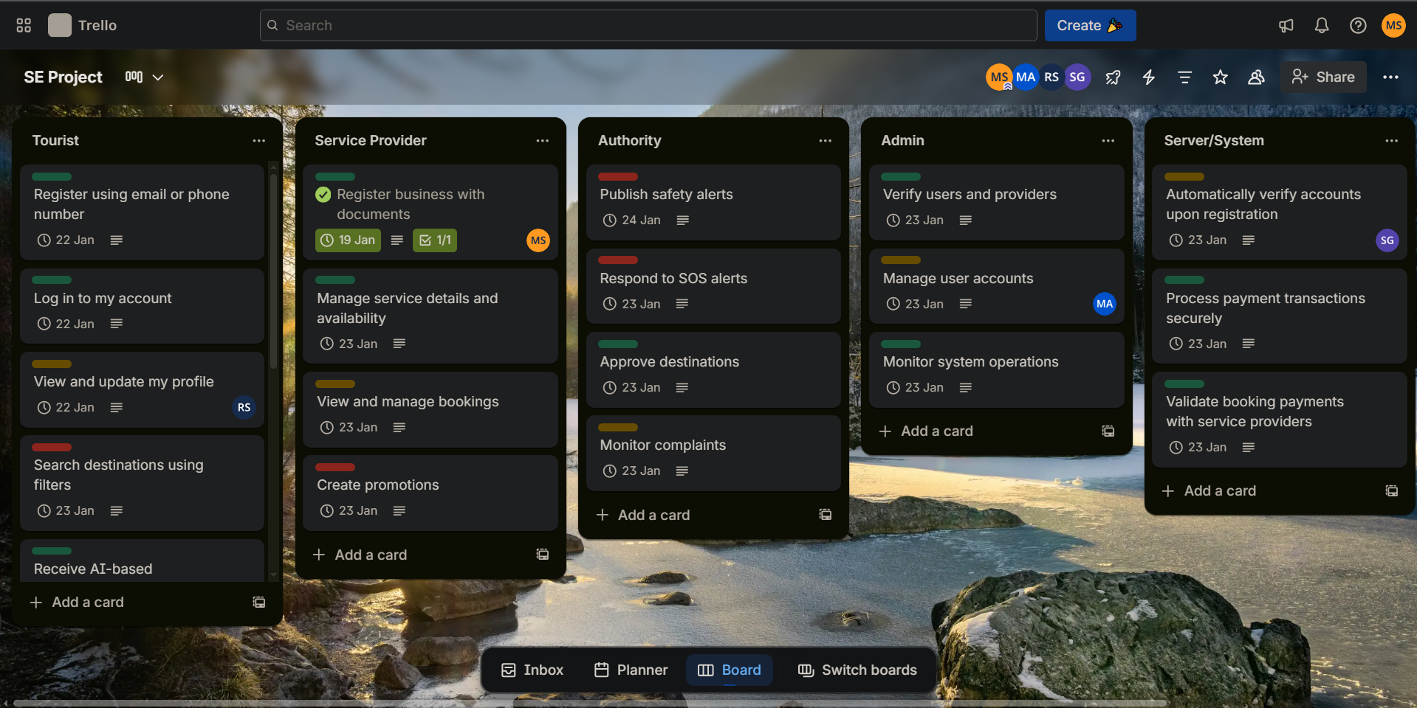

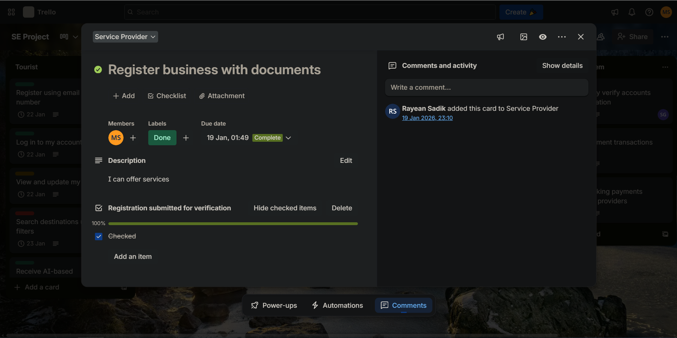

## ****2.3 Requirements Traceability Matrix****

## ****2.3.1 Functional Requirements****

**FR-1: User Registration**

The system shall allow tourists, service providers, authorities and administrators to register using an email address or phone number. During registration, users must provide mandatory information, and service providers must submit business details and verification documents. Account activation shall be completed through OTP verification.

**FR-2: User Authentication**

The system shall provide secure login functionality using verified credentials. Only authenticated users with active accounts shall be granted access to role specific dashboards and features.

**FR-3: Profile Management**

The system shall enable users to view and update their personal and role specific profile information. Any changes made shall be validated and securely stored to maintain data integrity.

**FR-4: Password Management and Recovery**

The system shall allow users to change their passwords after proper verification. It shall also support password recovery using OTP verification to ensure secure account access.

**FR-5: Destination Search**

The system shall allow tourists to search travel destinations using filters such as distance, rating, budget, safety level and category. Search results shall display essential destination information for comparison.

**FR-6: Nearby Attraction Discovery**

The system shall display nearby attractions, services, and points of interest based on the users current or selected destination. Map based visualization shall be used to improve user understanding and navigation.

**FR-7: AI-Based Recommendations**

The system shall provide personalized destination and travel recommendations based on user preferences, previous activities and trending travel data. Recommendations shall be continuously refined using user interactions.

**FR-8: Smart Trip Planning**

The system shall generate optimized day wise travel itineraries considering time, distance, budget and user preferences. Users shall be able to modify and save generated trip plans.

**FR-9: Service Search**

The system shall allow tourists to search hotels, restaurants, transportation, and activities using category specific filters. Search results shall show availability, pricing, ratings and service details.

**FR-10: Booking Management**

The system shall allow tourists to request, view, modify and cancel service bookings. Booking status updates shall be displayed clearly to both tourists and service providers.

**FR-11: Payment Processing**

The system shall support secure online payments using multiple payment methods. Upon successful payment, the system shall confirm the booking and generate a digital receipt.

**FR-13: Safety Alert System**

The system shall allow authorized authorities to publish safety alerts related to weather, security or emergencies. Tourists shall receive alerts based on their current location or planned destinations.

**FR-14: Rating and Review System**

The system shall allow tourists to submit ratings and reviews for destinations and services after completion. Only verified users shall be permitted to submit reviews to ensure authenticity.

**FR-15: Administrative Management**

The system shall provide administrators with tools to verify accounts, manage users, handle complaints, and monitor system performance. Administrators shall enforce platform policies to ensure system reliability.

## 2.3.2 Non-Functional Requirements

**NFR-1: Availability**

Measures system uptime and accessibility.

**Example:** TravelBuddy shall be 99.5% available on weekdays between 6:00 AM–12:00 AM and 99.9% during peak hours (6–10 PM) so tourists can access trip planning, bookings and SOS features anytime.

**NFR-2: Performance**

Defines system response speed and efficiency.

**Example:** Destination search with up to five filters shall return results within 2 seconds over a standard 4G connection. Emergency SOS activation shall transmit alerts to authorities within 3 seconds.

**NFR-3: Efficiency**

Measures resource usage like storage, memory and bandwidth.

**Example:** The TravelBuddy mobile app shall use no more than 150 MB of storage and 5 MB/day of background data when GPS tracking and notifications are active.

**NFR-4: Flexibility**

Ability to add new features with minimal changes.

**Example:** Adding a new service type shall be completed in less than 1 day by a developer familiar with the system.

**NFR-5: Integrity**

Protects data from unauthorized access or loss.

**Example:** Only authenticated tourists can view their own bookings, only service providers can view requests for their businesses, only authorities/admins can access SOS alerts and real time location tracking.

**NFR-6: Interoperability**

Ability to exchange data with external systems.

**Example:** TravelBuddy shall allow trip itinerary export in Calendar format for Google, Apple and Outlook calendars.

**NFR-7: Reliability**

System consistently performs functions correctly.

**Example:** No more than 1 out of 1,000 booking transactions shall fail to record properly. The SOS emergency feature shall successfully transmit alerts in 99.9% of activation attempts.

**NFR-8: Robustness**

System works properly under unexpected conditions.

**Example:** If the network disconnects while viewing a trip plan, the app shall cache the itinerary locally and sync changes once connectivity is restored.

**NFR-9: Usability**

Ease of use and intuitive operation.

**Example:** First time tourists shall complete a destination search and view results within 5 minutes without any help.

**NFR-10: Maintainability**

Ease of modifying or fixing the system.

**Example:** A developer shall update destination search filters, including testing in less than 8 hours.

**NFR-11: Reusability**

Components can be reused in other applications.

**Example:** The payment module shall be reusable in other booking or e-commerce apps with less than 5% code changes.

**NFR-12: Testability**

Ease of verifying correctness and finding defects.

**Example:** Maximum cyclomatic complexity of any function shall not exceed 10. Trip planning, recommendation and booking modules shall have less than 90% unit test coverage to ensure functionality.

# 3. SOFTWARE DESIGN

# 3.1 System Design

# 3.1.1 Use Case Diagram

**Description**

The system allows Tourists, Service Providers, and Authorities to Register/Login with email or phone number, where the Server automatically verifies accounts. Tourists can Manage Profile to update personal information and preferences, then Search Destinations by applying filters for distance, rating, price and with additional features to View Nearby Attractions. Moreover, AI View Recommendations based on preferences. Users can Generate Trip Plan to create optimized single-day or multi-day trips, then Search/Booking Services for hotels, transportation and restaurants which includes Process Payment that connects to Validate Booking Payment handled by Server. Tourists access Get Safety Alerts for real-time warnings and can trigger Emergency Helpline to send live location to authorities, while they can also Rate and Review Services after trips. Service Providers Verify Business Documents during registration, then Update Service Details and Manage Bookings by viewing requests, Accept/Reject Bookings based on availability and also create Special Offers/Discounts. Admin performs Verify Accounts by checking documents, uses Manage Accounts, can Ban/Suspend Accounts for violations, Maintain System for performance. Authorities Provide/Publish Safety Alerts to inform tourists, Approve New Destinations for official recognition, Verify Service Provider Legitimacy for trust badges, and Monitor Reports/Complaints to ensure tourist safety and service quality across the platform.

**Diagram**

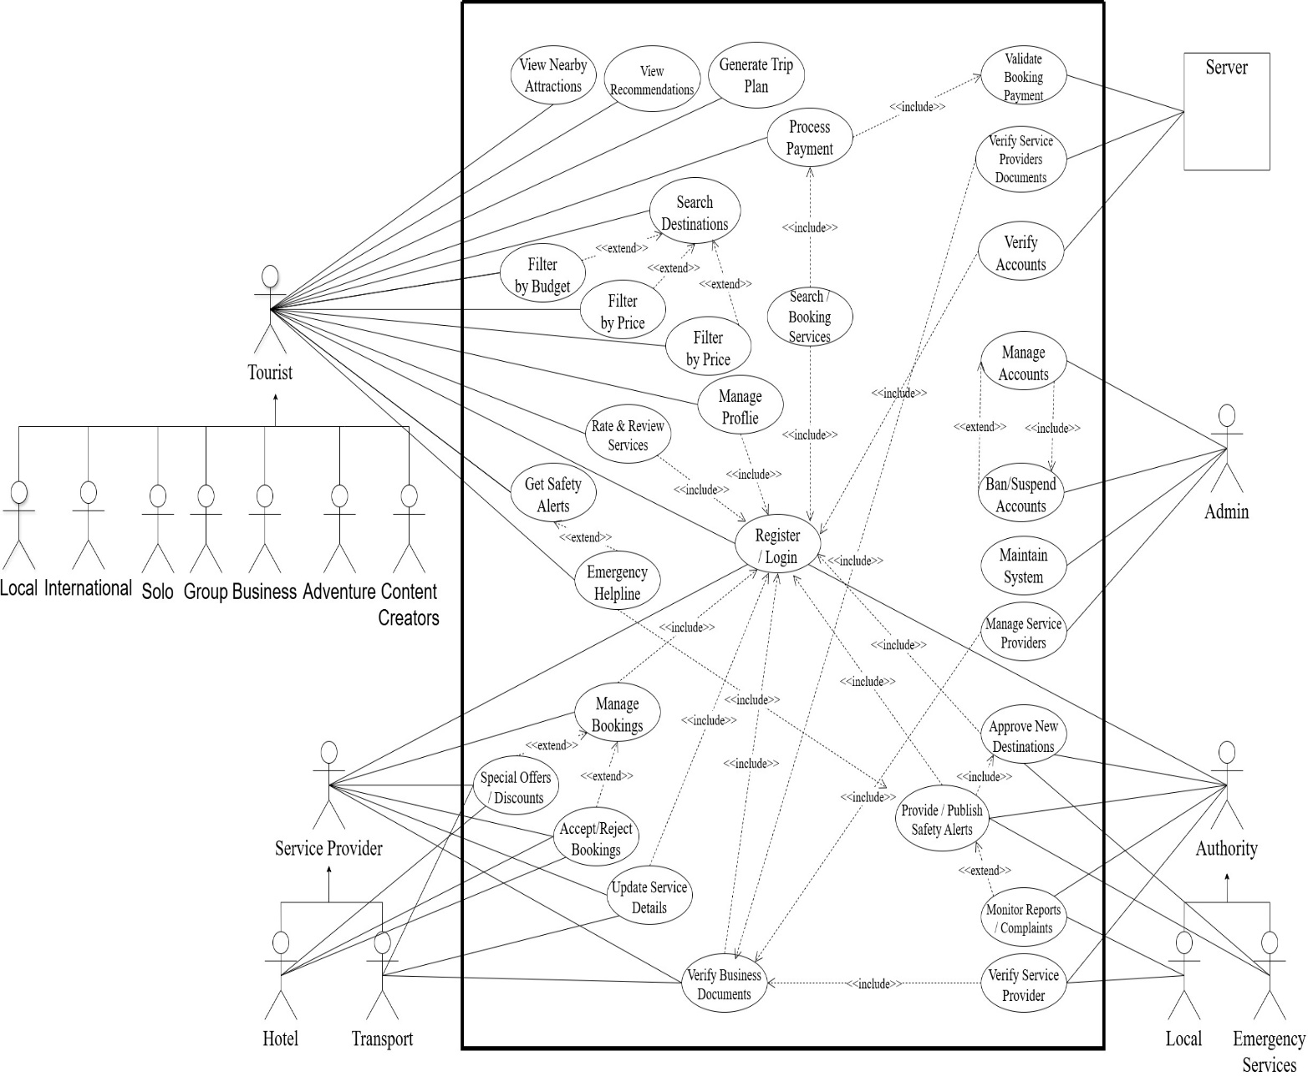

**3.1.2 Class Diagram**

**Description**

**The class diagram illustrates the static structure of the *TravelBuddy* system using UML class notation. The User class is designed as the parent class and contains common private attributes such as userId, name, email, phone, and password, along with public operations like register(), login(), and updateProfile(). The Tourist, ServiceProvider, Authority and Admin classes inherit from the User class, representing different system roles with specialized responsibilities. The Tourist class manages travel-related functionalities including destination search, trip plan generation, booking services, and emergency SOS activation. The ServiceProvider class handles business registration, service management, and booking management, while the Authority class is responsible for publishing safety alerts and responding to emergency reports. The Admin class manages system-level operations such as account verification and system maintenance. The Tourist class is associated with the TripPlan class to generate multiple travel itineraries, and with the Booking class to make service reservations. The Booking class has a composition relationship with the Payment class, indicating that payment cannot exist without a booking. The Authority class is associated with the SafetyAlert class to manage safety information. All attributes are marked as private using the ‘−’ symbol, and all methods are marked as public using the ‘+’ symbol, following standard UML conventions.**

**Diagram**

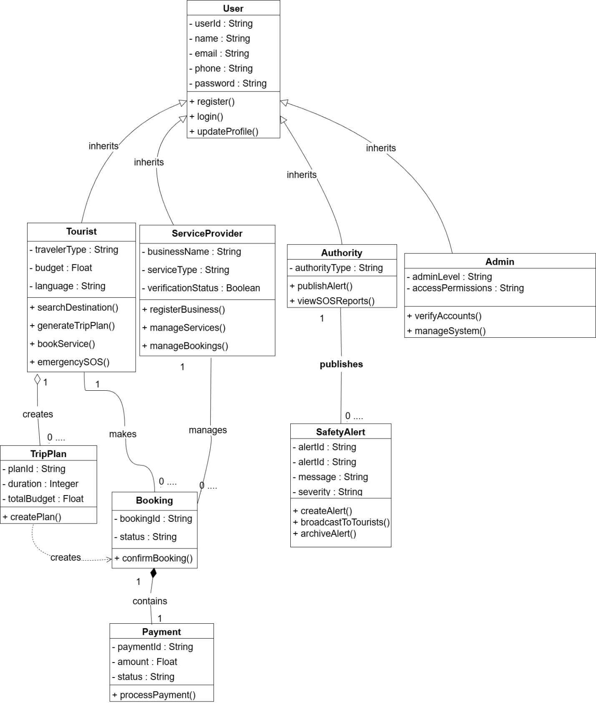

# 3.1.3 Activity Diagram

**Description**

The activity diagram represents the complete workflow of the TravelBuddy system and demonstrates how different actors interact with the system using swimlanes. The diagram consists of four swimlanes: **Tourist, System, Service Provider**, and **Authority**. The activity flow begins in the Tourist swimlane when the user opens the application and performs login or registration. The control then moves to the System swimlane, where the system validates the user and displays the dashboard. The tourist searches for destinations and applies filters such as budget, safety, and distance. The system generates a smart itinerary and displays nearby attractions and recommendations. A decision node checks whether the tourist is satisfied with the results; if not, the flow returns to the filtering step. If satisfied, the tourist selects a service to book. The system checks service availability and forwards the booking request to the Service Provider, who either accepts or rejects the booking. If the booking is accepted, the tourist confirms the reservation and the system processes the payment. During the trip, the system continuously monitors safety alerts published by the Authority. If an emergency occurs, the tourist activates the SOS feature, which triggers a parallel flow where the system captures the user’s location and notifies the Authority. The Authority responds to the emergency and provides assistance. The activity flow ends when the trip is completed or the emergency is resolved.

**Diagram**

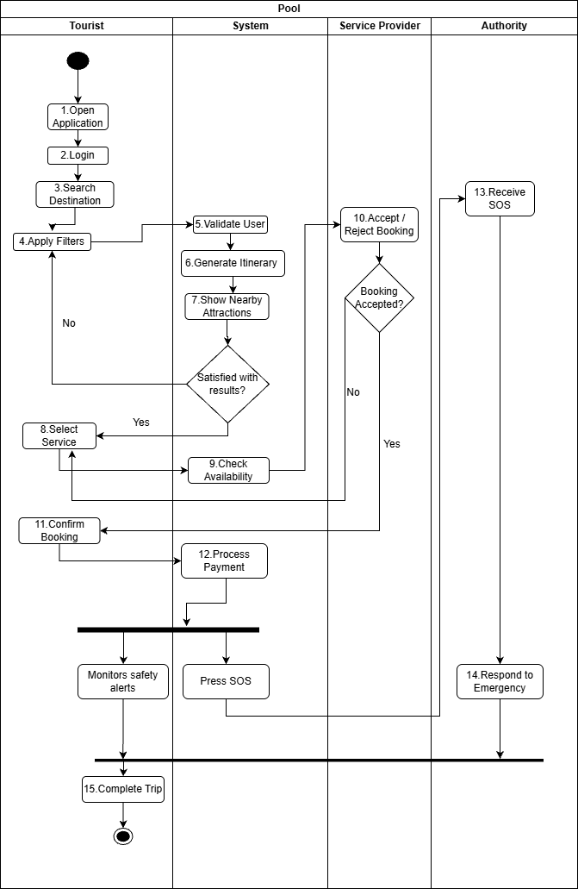

## UI / Wireframe Design using Figma

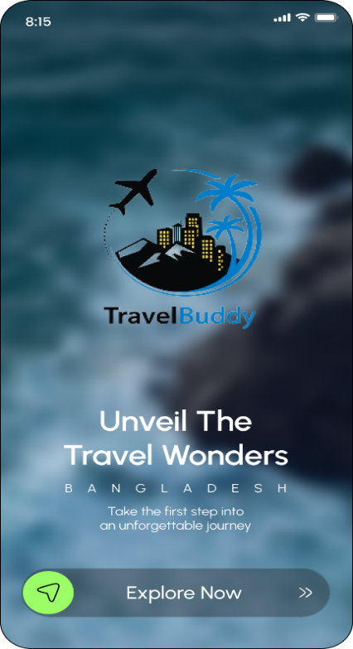 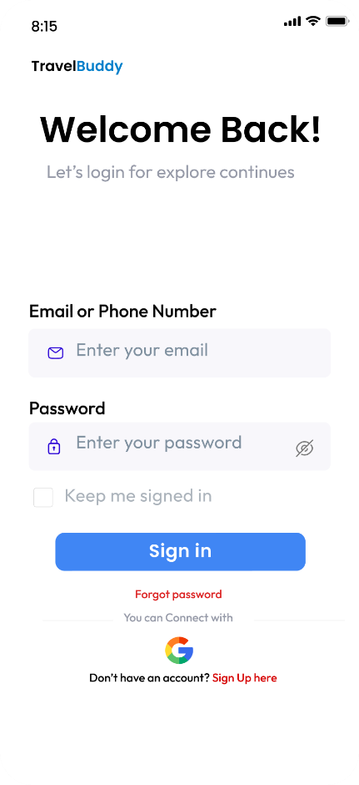

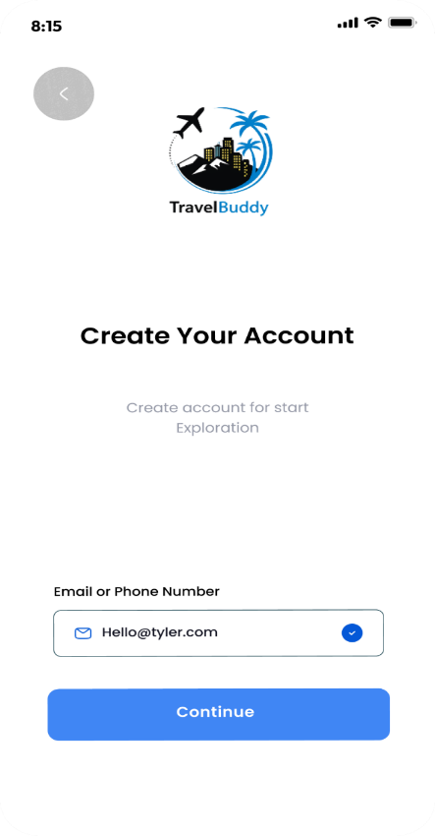 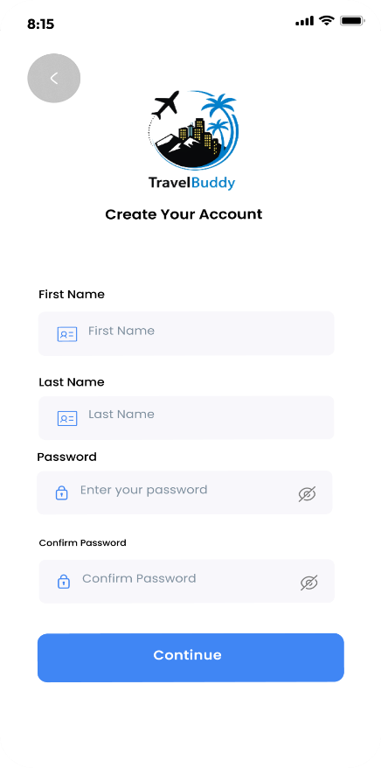

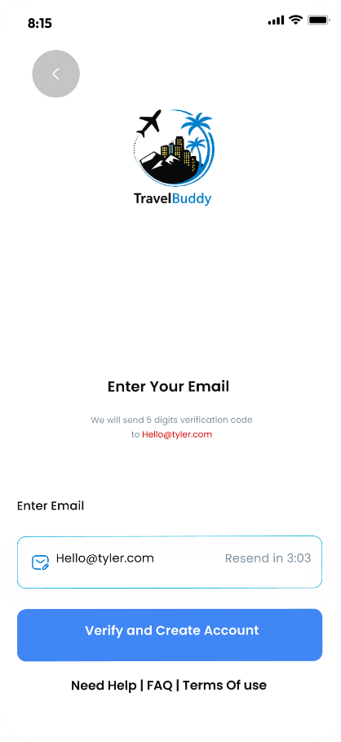 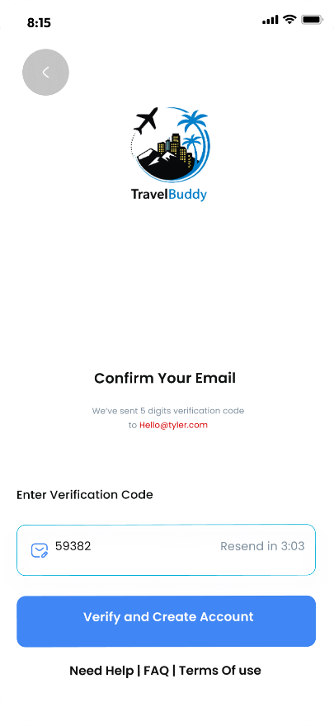

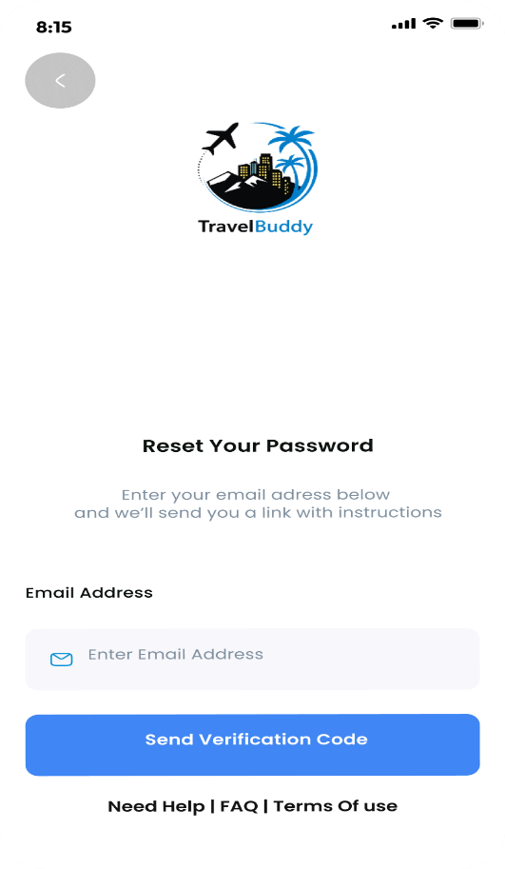 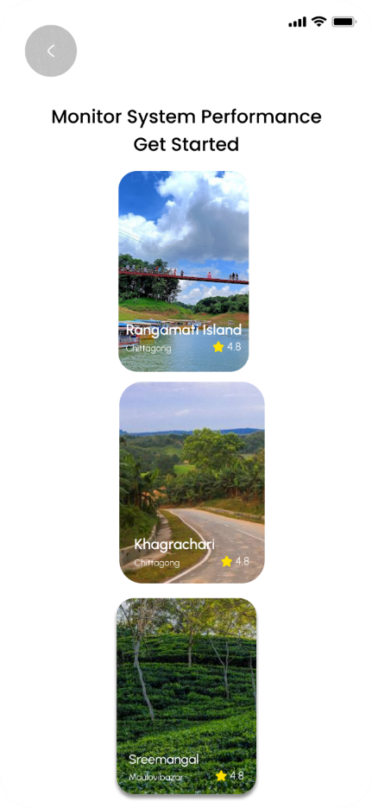

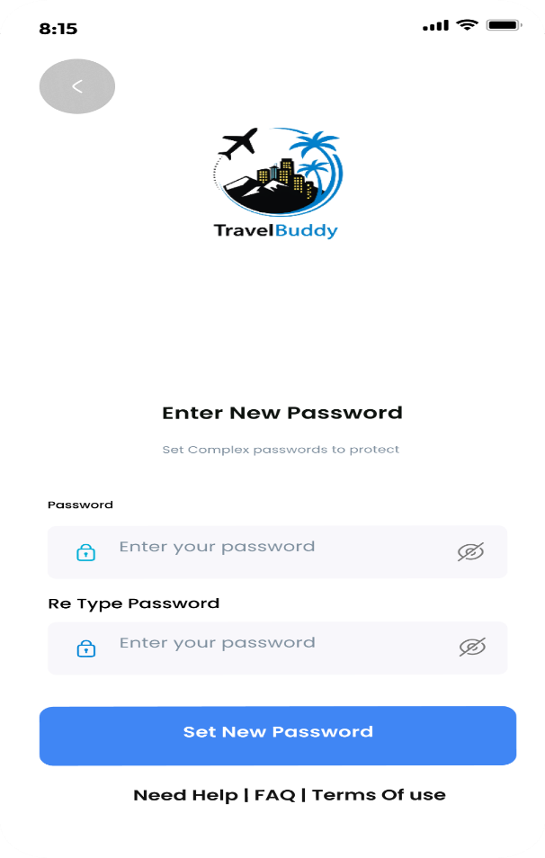 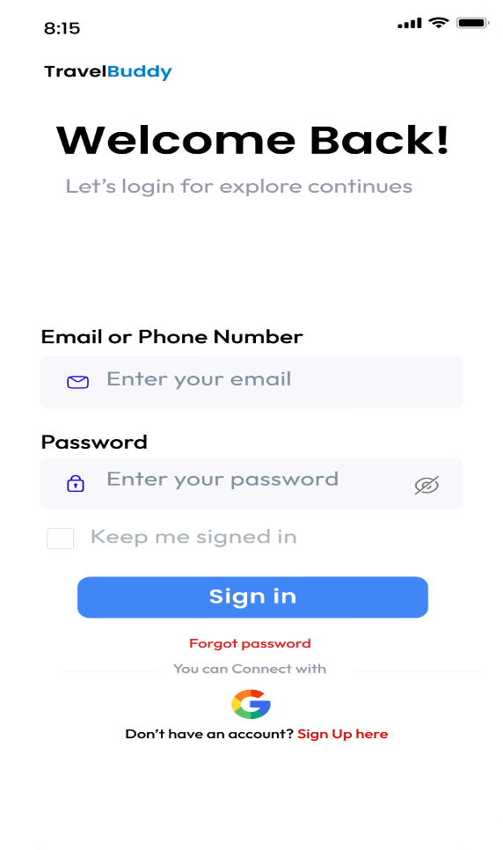

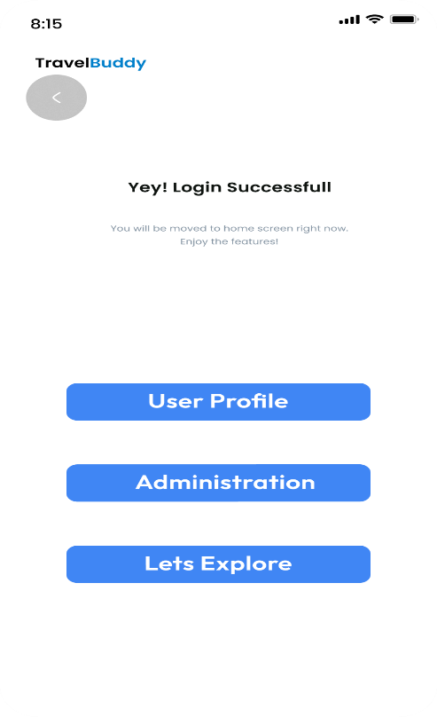 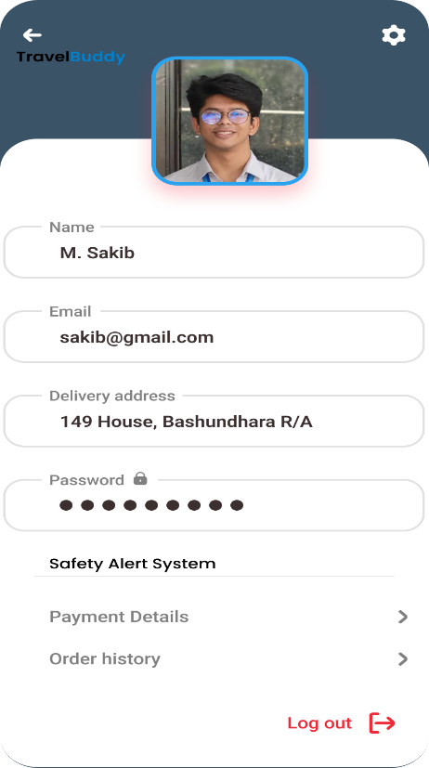

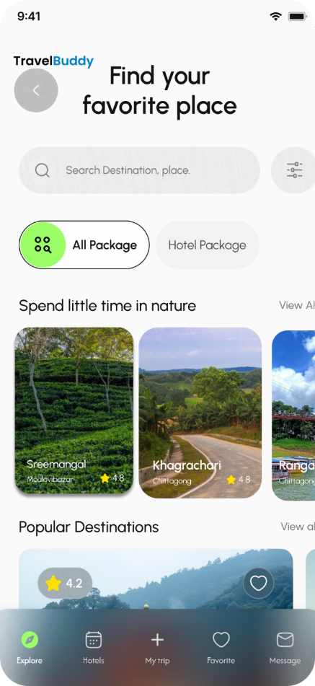 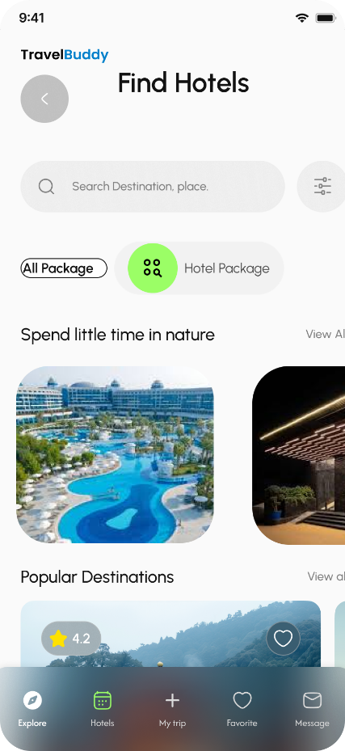

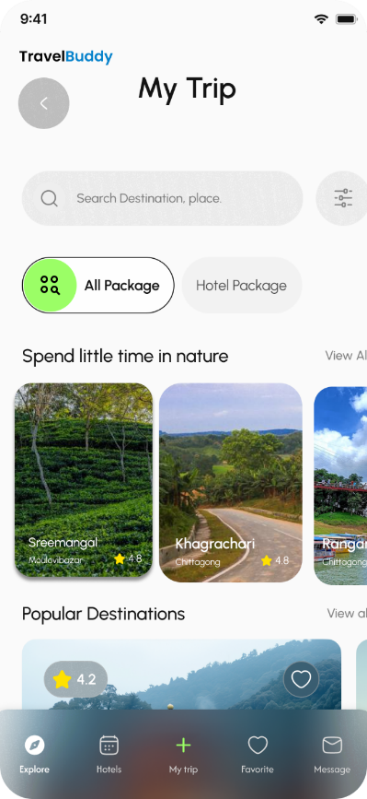 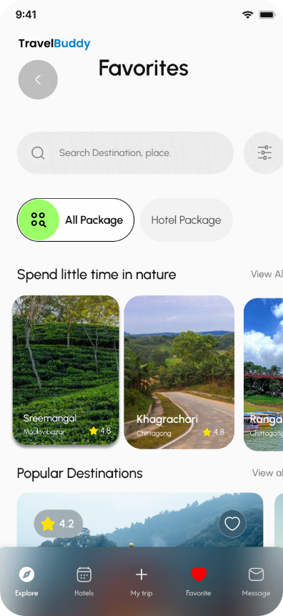

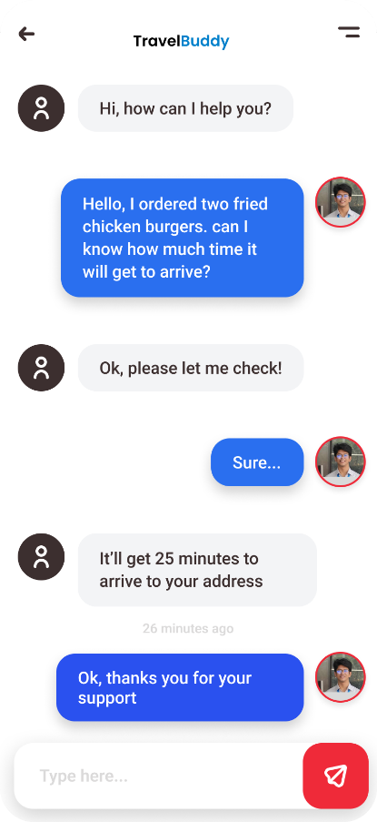 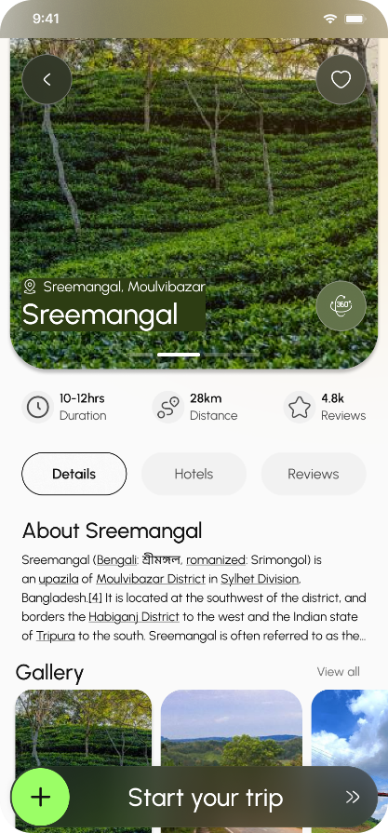

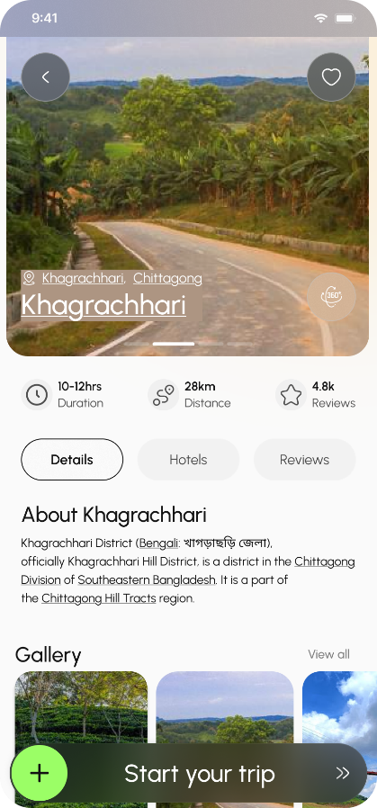 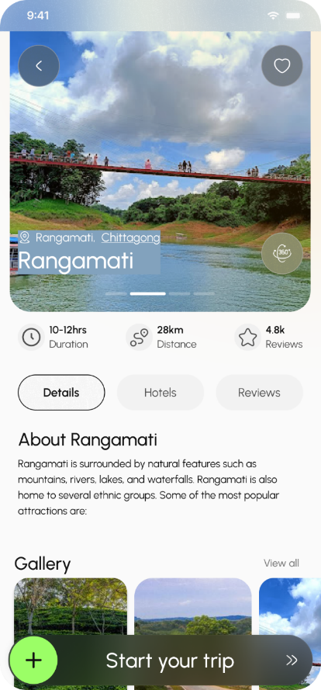

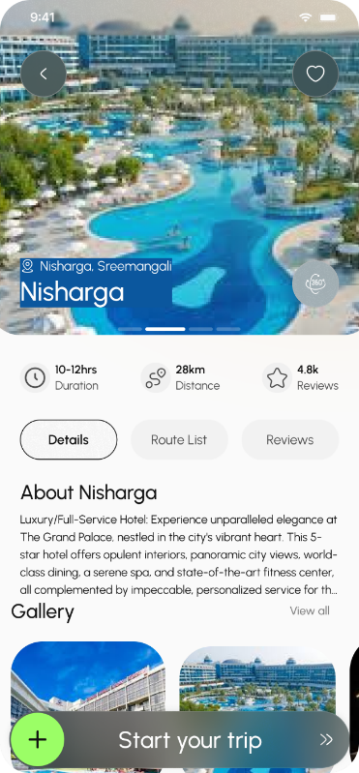 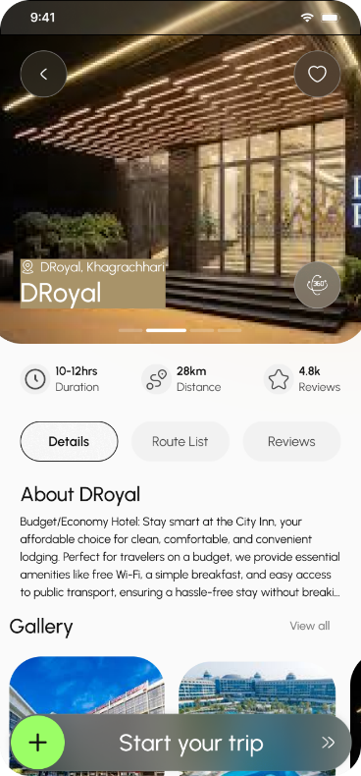

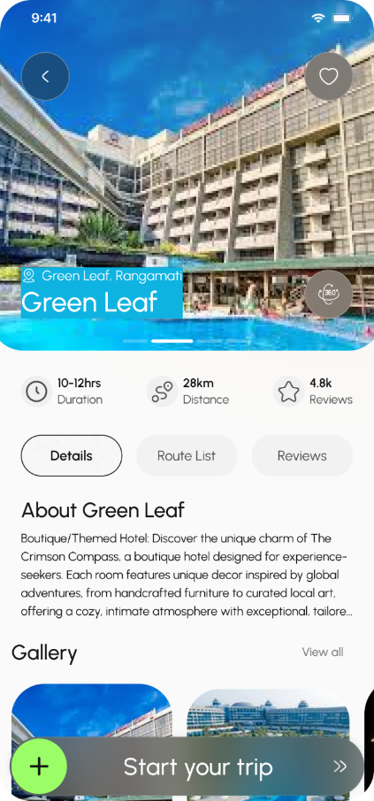 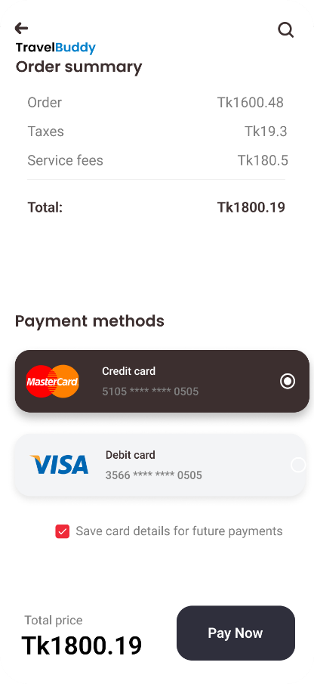

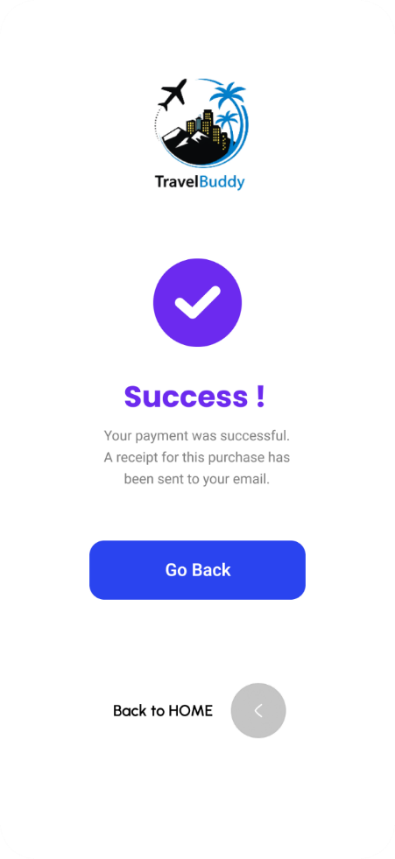 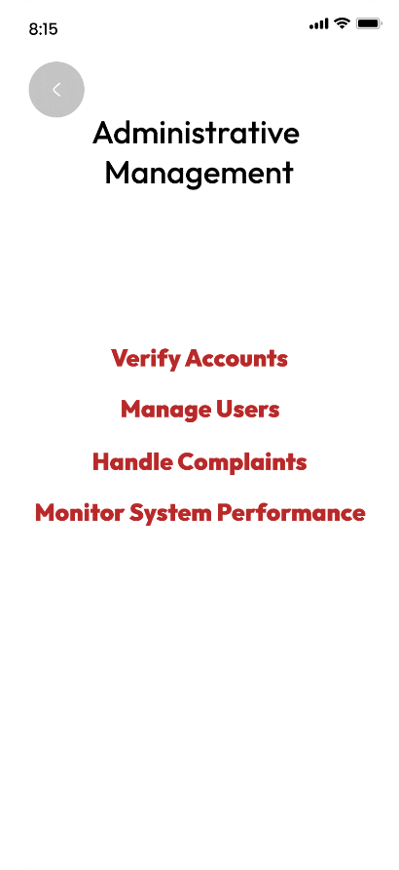

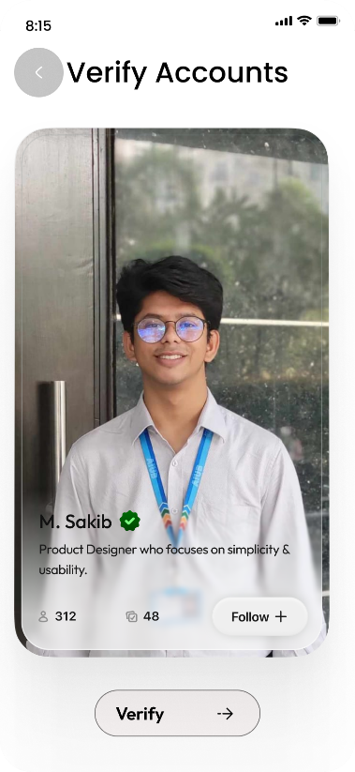 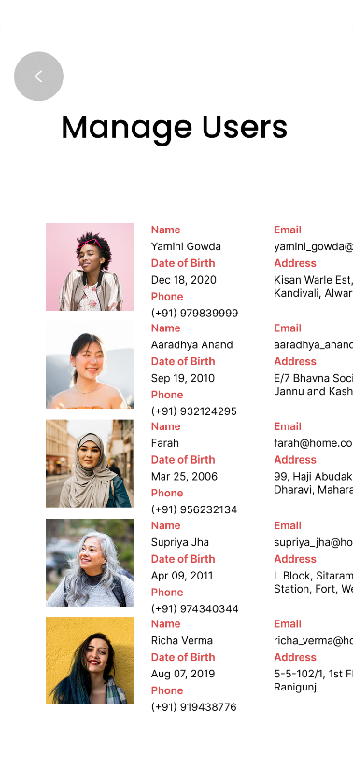

4. GIT WORKFLOW

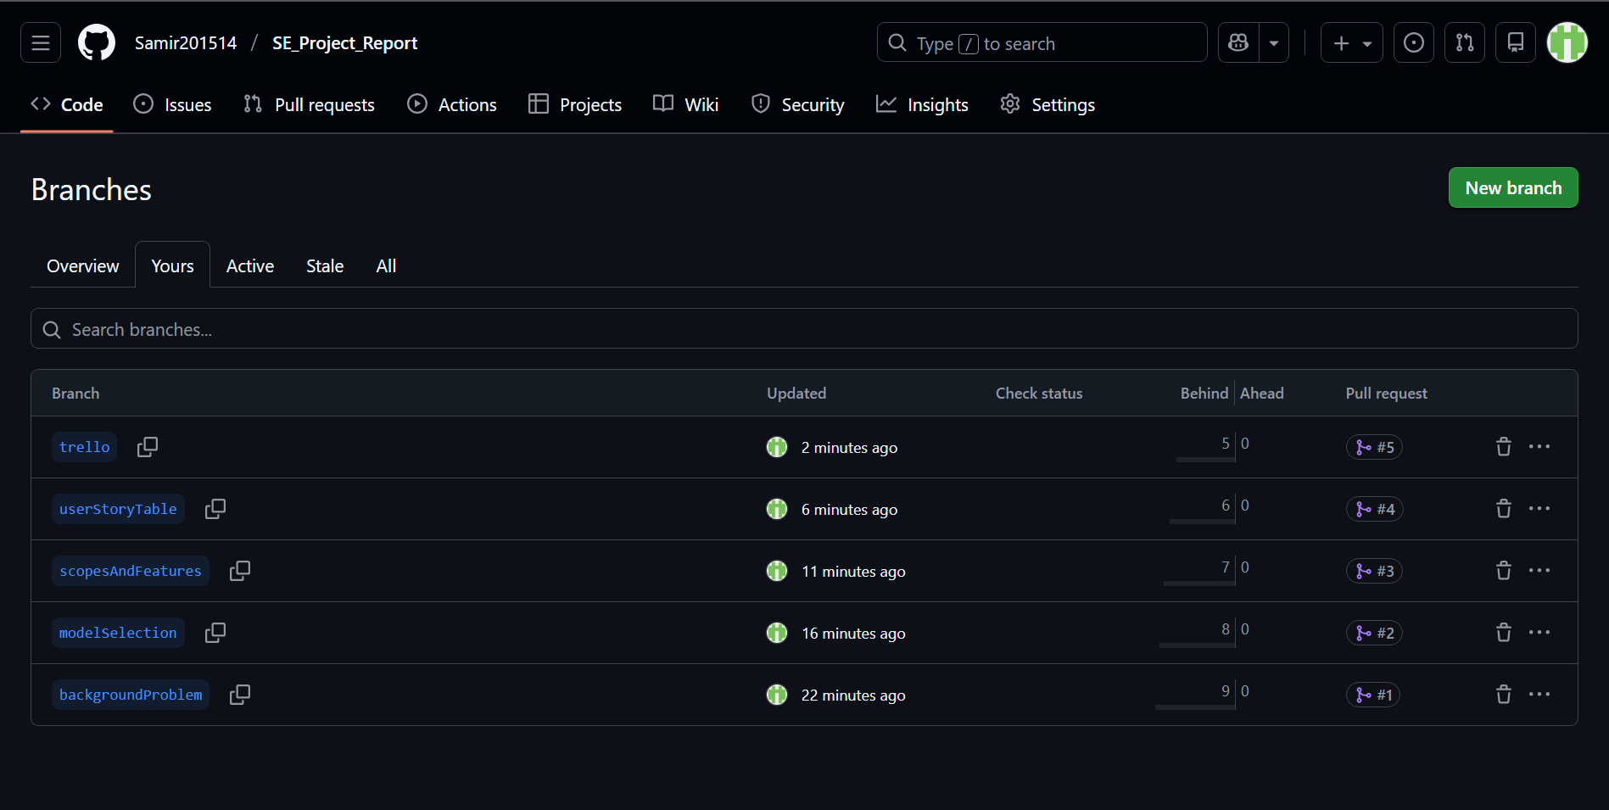

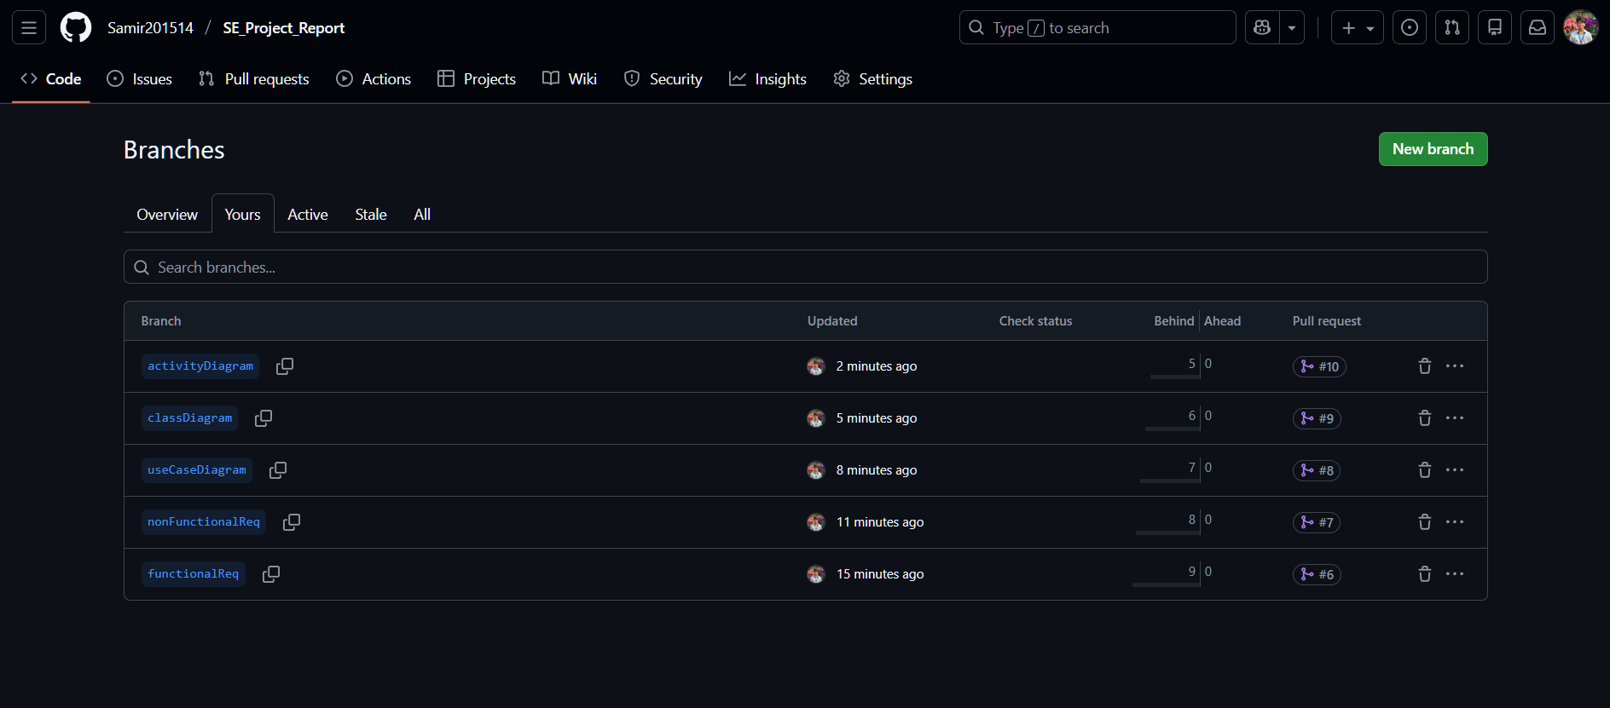

# 5. SOFTWARE TESTING

|  |  |  |  |  |
| --- | --- | --- | --- | --- |
| Project Name: TravelBuddy | | | Test Designed By: SHANTONU BARUA | |
| Test Case ID: **TC_SB_01** | | | Test Designed Date: 05/01/2026 | |
| Test Priority (Low/Medium/High): High | | | Test Executed By: SHANTONU BARUA | |
| Module Name: User Registration | | | Test Execution Date: 12/01/2026 | |
| Test Title: Verify tourist registration with email and OTP | | |  | |
| Description: Test tourist registration with email and OTP verification | | |  | |
| Precondition: User not registered; valid email available | | | | |
| Dependencies: Email & OTP services operational | | | | |
| Test Steps | Test Data | Expected Results | Actual Result | Status (Pass/Fail) |
| 1. Open registration page and select Tourist role 2. Enter email and password 3. Submit registration form 4. Enter received OTP 5. Complete registration | Email, Password, OTP code | Account activated for login | As expected | Pass |

|  |  |  |  |  |
| --- | --- | --- | --- | --- |
| Project Name: TravelBuddy | | | Test Designed By: SHANTONU BARUA | |
| Test Case ID: TC_SB_02 | | | Test Designed Date: 05/01/2026 | |
| Test Priority (Low/Medium/High): High | | | Test Executed By: SHANTONU BARUA | |
| Module Name: Destination Search | | | Test Execution Date: 12/01/2026 | |
| Test Title: Verify destination search with filters | | |  | |
| Description: Test search using distance, price, and rating | | |  | |
| Precondition: Tourist logged in | | | | |
| Dependencies: Destination database | | | | |
| Test Steps | Test Data | Expected Results | Actual Result | Status (Pass/Fail) |
| 1. Open destination search page 2. Apply location and filters 3. Click search 4. Review results | Dhaka, 50km, 4 Star Hotel | Filters applied correctly and Shown Result Correctly | As expected | Pass |

|  |  |  |  |  |
| --- | --- | --- | --- | --- |
| Project Name: TravelBuddy | | | Test Designed By: SHANTONU BARUA | |
| Test Case ID: TC_SB_03 | | | Test Designed Date: 05/01/2026 | |
| Test Priority (Low/Medium/High): High | | | Test Executed By: SHANTONU BARUA | |
| Module Name: Emergency SOS | | | Test Execution Date: 12/01/2026 | |
| Test Title: Verify SOS alert transmission | | |  | |
| Description: Test emergency SOS alert to authorities | | |  | |
| Precondition: Tourist logged in and GPS enabled | | | | |
| Dependencies: Location & alert system | | | | |
| Test Steps | Test Data | Expected Results | Actual Result | Status (Pass/Fail) |
| 1. Open destination search page 2. Apply location and filters 3. Click search | Dhaka, 50km, 4 Star Hotel | Shown Safe areas Correctly | As expected | Pass |

|  |  |  |  |  |
| --- | --- | --- | --- | --- |
| Project Name: TravelBuddy | | | Test Designed By: M.SAKIB SADMAN ARIAN | |
| Test Case ID: TC_MSA_01 | | | Test Designed Date: 08/01/2026 | |
| Test Priority (Low/Medium/High): High | | | Test Executed By: M.SAKIB SADMAN ARIAN | |
| Module Name: Trip Planning | | | Test Execution Date: 15/01/2026 | |
| Test Title: Verify automated trip itinerary generation for single-day trip | | |  | |
| Description: Test smart trip planner generates optimized itinerary for one-day trip | | |  | |
| Precondition: User logged in as tourist. Destinations selected for trip planning | | | | |
| Dependencies: Trip planning algorithm functional. Destination data available | | | | |
| Test Steps | Test Data | Expected Results | Actual Result | Status (Pass/Fail) |
| 1. Navigate to trip planner 2. Select trip duration and add destinations 3. Set budget constraint 4. Click "Generate Itinerary" 5. View generated itinerary | Duration: 1 day (8 hours) Destinations: Lalbagh Fort, Ahsan Manzil, Sadarghat Budget: 1500 BDT | Generated showing visiting sequence, transportation, meal breaks, estimated costs and map rout | As expected | Pass |

|  |  |  |  |  |
| --- | --- | --- | --- | --- |
| Project Name: TravelBuddy | | | Test Designed By: M.SAKIB SADMAN ARIAN | |
| Test Case ID: TC_MSA_02 | | | Test Designed Date: 09/01/2026 | |
| Test Priority (Low/Medium/High): High | | | Test Executed By: M.SAKIB SADMAN ARIAN | |
| Module Name: Service Booking | | | Test Execution Date: 16/01/2026 | |
| Test Title: Verify hotel booking request submission to service provider | | |  | |
| Description: Test complete hotel booking workflow from search to request submission | | |  | |
| Precondition: User logged in as tourist. Hotel services available in database | | | | |
| Dependencies: Service provider accounts exist. Booking system operational | | | | |
| Test Steps | Test Data | Expected Results | Actual Result | Status (Pass/Fail) |
| 1. Navigate to services and select Hotels 2. Enter location and dates 3. Select hotel and click "Book Now" 4. Submit booking request | Location: Banani, Dhaka Dates: 25-27/01/2026 Price: 3000-6000 BDT Guests: 2 adults | Booking request created with ID, status "Pending Provider Confirmation" | As expected | Pass |

|  |  |  |  |  |
| --- | --- | --- | --- | --- |
| Project Name: TravelBuddy | | | Test Designed By: M.SAKIB SADMAN ARIAN | |
| Test Case ID: TC_MSA_03 | | | Test Designed Date: 10/01/2026 | |
| Test Priority (Low/Medium/High): Medium | | | Test Executed By: M.SAKIB SADMAN ARIAN | |
| Module Name: AI Recommendations | | | Test Execution Date: 17/01/2026 | |
| Test Title: Verify AI-powered destination recommendations based on user preferences | | |  | |
| Description: Test AI recommendation engine suggests relevant destinations | | |  | |
| Precondition: User logged in with saved preferences. User has search/booking history | | | | |
| Dependencies: Recommendation algorithm trained. User preference data available | | | | |
| Test Steps | Test Data | Expected Results | Actual Result | Status (Pass/Fail) |
| 1. Set user preferences 2. View recommendations | Interests: Historical sites, cultural Budget: Mid-range | At least 5 relevant recommendations displayed matching | As expected | Pass |

|  |  |  |  |  |
| --- | --- | --- | --- | --- |
| Project Name: TravelBuddy | | | Test Designed By: MD. ARAFAT RAHMAN SAMIR | |
| Test Case ID: TC_ARS_01 | | | Test Designed Date: 11/01/2026 | |
| Test Priority (Low/Medium/High): High | | | Test Executed By: MD. ARAFAT RAHMAN SAMIR | |
| Module Name: Payment Processing | | | Test Execution Date: 18/01/2026 | |
| Test Title: Verify secure payment processing for confirmed booking | | |  | |
| Description: Test payment workflow with credit card for hotel booking | | |  | |
| Precondition: Booking request confirmed by service provider. Payment due | | | | |
| Dependencies: Payment gateway integration active. Test card credentials available | | | | |
| Test Steps | Test Data | Expected Results | Actual Result | Status (Pass/Fail) |
| 1. Navigate to confirmed booking 2. Click "Pay Now"  3. Enter card details  4. Review payment  5. Confirm payment | Card: 4111 1111 1111 1111 Name: ARAFAT RAHMAN Expiry: 08/2028 CVV: 123 Amount: 9200 BDT (200 service charge) | Payment processed successfully, transaction ID, booking status updated to "Confirmed - Paid" | As expected | Pass |

|  |  |  |  |  |
| --- | --- | --- | --- | --- |
| Project Name: TravelBuddy | | | Test Designed By: MD. ARAFAT RAHMAN SAMIR | |
| Test Case ID: TC_ARS_02 | | | Test Designed Date: 12/01/2026 | |
| Test Priority (Low/Medium/High): High | | | Test Executed By: MD. ARAFAT RAHMAN SAMIR | |
| Module Name: Service Provider Management | | | Test Execution Date: 18/01/2026 | |
| Test Title: Verify service provider can accept booking request | | |  | |
| Description: Test service provider booking management and acceptance workflow | | |  | |
| Precondition: Service provider logged in. Pending booking request exists | | | | |
| Dependencies: Tourist booking request submitted. Notification system functional | | | | |
| Test Steps | Test Data | Expected Results | Actual Result | Status (Pass/Fail) |
| 1. Login as service provider 2. Navigate to booking requests 3. Review booking details and check availability 4. Click "Accept Booking" and confirm | Email: [email protected] Password: Hotel@2026 Booking: BR-2026-4528 | Display New Booking Request | As expected | Pass |

|  |  |  |  |  |
| --- | --- | --- | --- | --- |
| Project Name: TravelBuddy | | | Test Designed By: MD. ARAFAT RAHMAN SAMIR | |
| Test Case ID: TC_ARS_03 | | | Test Designed Date: 13/01/2026 | |
| Test Priority (Low/Medium/High): Medium | | | Test Executed By: MD. ARAFAT RAHMAN SAMIR | |
| Module Name: Rating and Review | | | Test Execution Date: 19/01/2026 | |
| Test Title: Verify tourist can submit rating and review after completed booking | | |  | |
| Description: Test review submission workflow with star rating and written feedback | | |  | |
| Precondition: Tourist has completed booking with check-out date passed | | | | |
| Dependencies: Booking record exists with completed status. Review system active | | | | |
| Test Steps | Test Data | Expected Results | Actual Result | Status (Pass/Fail) |
| 1.Navigate to completed bookings 2. Click "Write Review" 3. Rate overall 4. Write review text and upload photo 5. Submit review | Review: "Excellent stay with great location and helpful staff..."  Rating:  4.5 | Review submitted successfully | As expected | Pass |

|  |  |  |  |  |
| --- | --- | --- | --- | --- |
| Project Name: TravelBuddy | | | Test Designed By: RAYEAN SADIK | |
| Test Case ID: TC_RS_01 | | | Test Designed Date: 14/01/2026 | |
| Test Priority (Low/Medium/High): High | | | Test Executed By: RAYEAN SADIK | |
| Module Name: Safety Alerts | | | Test Execution Date: 19/01/2026 | |
| Test Title: Verify authority can publish safety alert to affected tourists | | |  | |
| Description: Test safety alert creation and broadcast to tourists in affected area | | |  | |
| Precondition: Authority logged in. Tourist users in affected area exist | | | | |
| Dependencies: Geolocation services active. Push notification system functional | | | | |
| Test Steps | Test Data | Expected Results | Actual Result | Status (Pass/Fail) |
| 1.Login as authority and navigate to alerts 2. Create new alert with title, description, severity 3. Define affected area on map 4. Set validity period and actions 5. Publish alert | Title: "Heavy Rainfall Warning" Description: "Heavy rainfall expected..." Severity: Warning (Orange) Area: Old Dhaka Duration: 19/01 6 PM - 11 PM | lert creation form displays, affected area highlighted, confirmation shows "342 affected tourists", alert broadcasted successfully | As expected | Pass |

|  |  |  |  |  |
| --- | --- | --- | --- | --- |
| Project Name: TravelBuddy | | | Test Designed By: RAYEAN SADIK | |
| Test Case ID: TC_RS_02 | | | Test Designed Date: 15/01/2026 | |
| Test Priority (Low/Medium/High): Medium | | | Test Executed By: RAYEAN SADIK | |
| Module Name: Admin Account Management | | | Test Execution Date: 18/01/2026 | |
| Test Title: Verify administrator can suspend user account for policy violation | | |  | |
| Description: Test admin account suspension workflow with reason and duration | | |  | |
| Precondition: Admin logged in. User account with violation report exists | | | | |
| Dependencies: Violation report submitted. User account active | | | | |
| Test Steps | Test Data | Expected Results | Actual Result | Status (Pass/Fail) |
| 1.Login as admin and navigate to user management 2. Search for reported user and view violation 3. Select "Suspend Account" 4. Set duration, reason, and notes 5. Confirm suspension | User ID: 23948 Duration: 30 days Reason: Fake Reviews Notes: "Multiple verified instances..." | User details with violation report displayed, suspension form completed, account suspended until 18/02/2026, status shows "Suspended" badge | As expected | Pass |

|  |  |  |  |  |
| --- | --- | --- | --- | --- |
| Project Name: TravelBuddy | | | Test Designed By: RAYEAN SADIK | |
| Test Case ID: TC_RS_03 | | | Test Designed Date: 16/01/2026 | |
| Test Priority (Low/Medium/High): Medium | | | Test Executed By: RAYEAN SADIK | |
| Module Name: Profile Management | | | Test Execution Date: 17/01/2026 | |
| Test Title: Verify user can update profile information and travel preferences | | |  | |
| Description: Test profile editing workflow with preference updates and validation | | |  | |
| Precondition: User logged in as tourist. Profile information exists | | | | |
| Dependencies: User account verified and active | | | | |
| Test Steps | Test Data | Expected Results | Actual Result | Status (Pass/Fail) |
| 1.Navigate to profile and click "Edit Profile" 2. Update phone, interests, budget, language 3. Save changes and verify OTP | Phone: +880 1712-345678 Interests: Add "Adventure", "Food" Budget: Mid-range Language: Bangla + English OTP: 749283 | Edit form opens with current data, updates accepted, OTP verification for phone change, profile updated successfully with all new information displayed | As expected | Pass |